**Module 1 Critical Thinking: Option 1**

Andrew Barnes

Colorado State University Global

CSC320-1

Dr. Schwartz

8/20/2023

**Pseudo Code**

Begin Program

Declare first_name as String

Declare last_name as String

Declare street_address as String

Declare city as String

Declare zipcode as String

Set first_name to “John”

Set last_name to “Doe”

Set street_address to “1234 Fake Street”

Set city to “St. Petersburg”

Set zipcode to “12345”

Print “First Name: “ followed by first_name

Print “Last Name: “ followed by last_name

Print “Street Address: “ followed by street_address

Print “City: “ followed by city

Print “Zipcode: “ followed by zipcode

End Program

**Source Code**

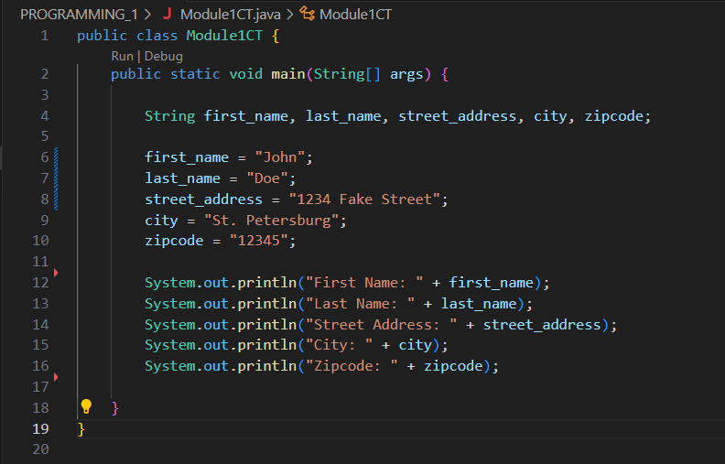

**Executing the Application**

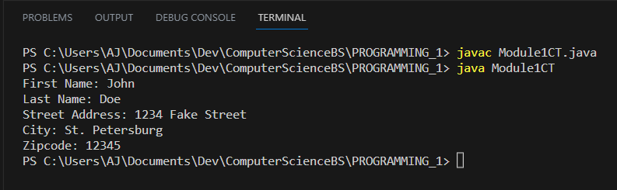

**Git Repository**

**Git Status**

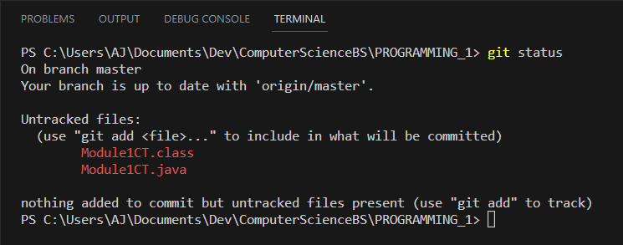

**Git Add**

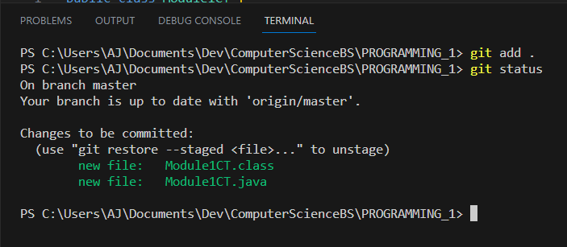

**Git Commit**

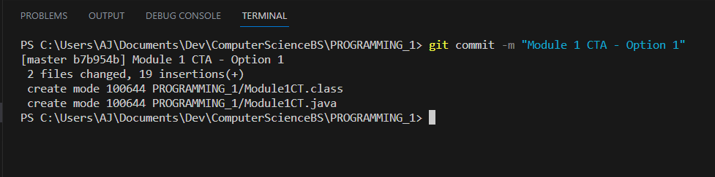

**Git Push**

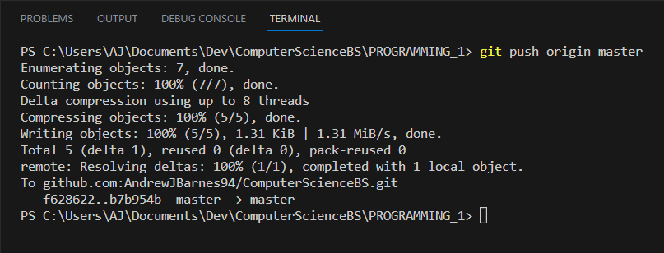

**GitHub Repository**

[**ComputerScienceBS/PROGRAMMING_1 at master · AndrewJBarnes94/ComputerScienceBS (github.com)**](https://github.com/AndrewJBarnes94/ComputerScienceBS/tree/master/PROGRAMMING_1)